**Week Six – May 18-24:** Study the Diamante and Haiku poem forms. You will need to submit two examples of each of these for a total of **4** poems this week. These two are harder than the first two and will take some practice. Use a dictionary to check your syllables.

## 3. What is a Diamante Poem?

What is a diamante? It is a **seven-line poem** that takes the shape of a **diamond.** But there is more to it than that! A diamante is a poem about opposites. Here is one about a lion and a lamb.

***Lion***  
*Majestic, proud*  
*Roaring, snarling, prowling*  
*Mane, muscle . . . Fleece, fluff*  
*Bleating, leaping, grazing*  
*Meek, gentle*  
***Lamb***

Diamantes rely instead on a carefully measured number of words to **describe two opposing things, places, emotions, or ideas**.

As you can see from the “Lion and Lamb” diamante, a series of **intentionally chosen words** tells about the first subject. Halfway through, a set of opposing words describes the second subject. Our sample poem starts with a feeling of strength, power, and pride before the tone switches to one of softness, gentleness, and peace.

How do I write a diamante poem?

To write a diamante poem you must follow the **poem’s simple structure**. This diamond-shaped poem always has **seven lines** that follow this sequence:

**Line A:** Topic A (must be a noun)  
**Line B:** Two vivid adjectives that describe Topic A  
**Line C:** Three interesting “-ing” action verbs that describe Topic A  
**Line D:** Two concrete nouns about Topic A and two about Topic G  
**Line E:** Three interesting “-ing” action verbs that describe Topic G  
**Line F:** Two vivid adjectives that describe Topic G  
**Line G:** Topic G (must be a noun)

Here is another diamante example:

***Light****Clear, brilliant*  
*Glowing, shining, revealing*  
*Mirror, candle . . . Whisper, shadow*  
*Deepening, sleeping, shrouding*  
*Black, quiet*  
***Darkness***

<https://writeshop.com/writing-diamante-poem/>

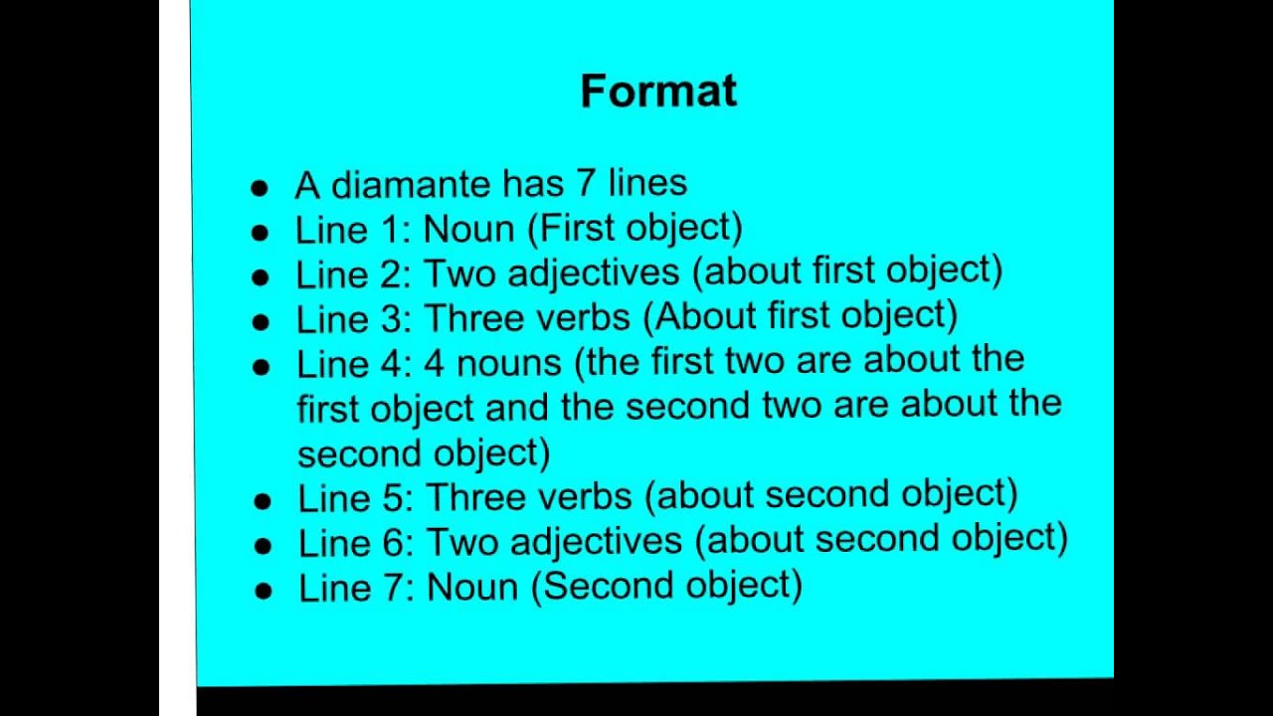

**Source: *https://www.bing.com/images/search?view=detailV2&ccid=Dlf4AZ3I&id=4934B3C3A1F224A32003C6D15D862370D73FCD03&thid=OIP.Dlf4AZ3ISBLDluwUSt1l6QHaEK&mediaurl=https%3a%2f%2fi.ytimg.com%2fvi%2f7Zb8b4oKH5Y%2fmaxresdefault.jpg&exph=720&expw=1280&q=diamante+poem+definition&simid=608022920492420782&selectedIndex=0&ajaxhist=0***

**4. What is a Haiku Poem?**

This ancient form of poem writing is renowned for its small size as well as the precise punctuation and syllables needed for its three lines. It is of ancient Japanese origin. It contains 17 syllables (in total) in 3 lines of five, seven, five syllables. Haiku poems are typically about nature and usually about a specific season. Writing a haiku requires careful attention to the syllables in words (you may need to use a dictionary to help determine the syllables).

Source: <https://www.familyfriendpoems.com/poems/other/haiku/>

**Peacefulness**

© Paul Holmes

Published: July 18, 2019

Calm as a river  
Tranquility in my heart  
Blue summer skies reign.  
Source: <https://www.familyfriendpoems.com/poem/peacefulness-haiku>

**Haiku Year (each month is a Haiku poem – for a total of 12 Haiku poems)**

© Paul Holmes [**more by Paul Holmes**](https://www.familyfriendpoems.com/user/paul-holmes/)

Published: May 2014

JANUARY  
Delightful display  
Snowdrops bow their pure white heads  
To the sun's glory.  
  
FEBRUARY  
Fresh green buds appear  
Indicating spring will soon  
Energize us all.   
  
MARCH  
Lambs gambol in fields  
Frisky with the joys of life  
Bleating happily.  
  
APRIL  
Bluebells stand so proud  
Beneath trees so sparsely dressed  
Fresh green leaves unfold.   
  
MAY  
Much awaited sound  
Echoes heard amid dense trees   
Cuckoo has arrived.  
  
JUNE  
Parks and gardens burst  
With sounds and vibrant colours  
Perfect harmony.  
  
JULY  
Beaches become full  
Of families having fun  
In sand and big waves.  
  
AUGUST  
Ripe golden harvest  
Burning sun in azure skies  
Labours rewarded.   
  
SEPTEMBER  
Swallows congregate  
On telephone wires ready  
To migrate down south.   
  
OCTOBER  
Red and gold leaves fall,  
Crunchy as cornflakes beneath  
Feet on a crisp morn.  
  
NOVEMBER  
Frosty webs sparkle  
In the early morning sun  
Brightly bejeweled.  
  
DECEMBER  
First few flakes of snow  
Dust gardens like icing on  
A chocolate cake.

Source: <https://www.familyfriendpoems.com/poem/haiku-year>